**Low-Level Architecture and Data Models**

**P05:HR MANAGEMENT SYSTEM**

**<team member names & ids>**

| **Student ID** | **Name** |
| --- | --- |
| **22100289** | **Mohammad Yousuf** |
| **22100230** | **Javeria Tariq** |
| **22100260** | **Talha Nasir** |
| **22100303** | **Ali Adnan Arif** |
| **22100062** | **Aamina Mariam** |

| **Content** | **Totals** | **Obtained** |
| --- | --- | --- |
| Architecture diagram | 30 | 10 |
| Architecture justification | 20 | 10 |
| E/R diagram | 30 | 30 |
| E/R diagram description | 20 | 15 |
| Late submission |  |  |
| **Total** | **100** | **65** |
| **Individual Evaluation** |  |  |
|  |  |  |

**Table of Contents**

1. Introduction 3

2. System Architecture 4

2.1 Architecture Diagram—As it is in the prototype code 4

2.2 Architecture Diagram—As it should-be 4

3. Data Models 5

4. Tools and Technologies 6

5. Who Did What? 7

6. Review checklist 7

# Introduction

The Human resource management system covers many HR aspects from application to management to promotions. The software keeps track of an organization’s employees and provides analytics of their performance using relevant KPIs. The software combines a number of systems and processes to ensure the ease of management in human resources and business processes. The HRMS software helps HR professionals manage the modern workforce.

Our aim is to assist companies in running effectively and efficiently. The system is a suite of software that companies can use to regulate their internal HR functions. Employee data management, recruitment, benefits, training, talent management, employee engagement, and employee attendance include some of the features our software will provide.

# System Architecture

## Architecture Diagram—As it is in the prototype code

The following comments apply to both the architecture diagrams:

1. Which architectural pattern(s) are you using?
2. Where do your application components are fit in? For instance, there would be some view components in your system, what are their names and where would you place them in this diagram? Similar comments hold for controller and model components.
3. Interaction between components is not clear.

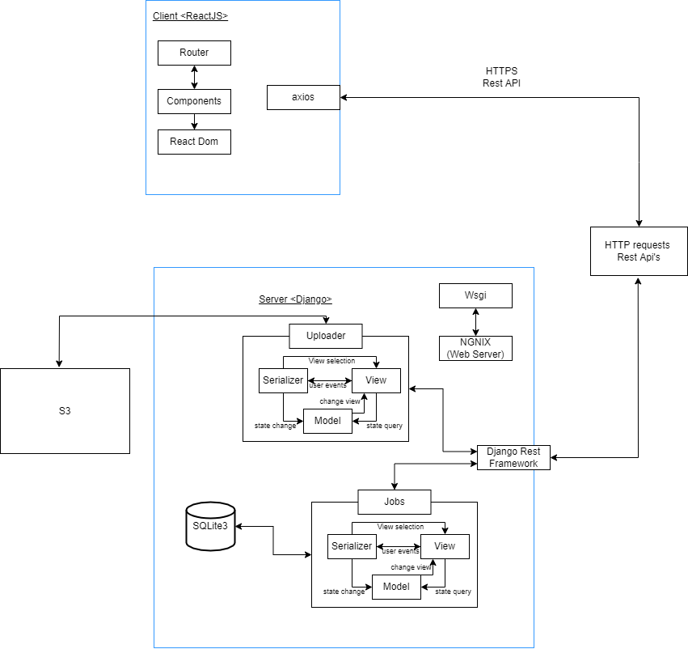

## Architecture Diagram—As it should-be

We are using a mix of 2 architectural patterns for our diagrams namely the Layered architecture and MVC architecture. Since we have a Django server we will have a Model View Serializer architecture instead of the MVC architecture.

At the backend we have only 1 server which is divided into 2 major components i.e Jobs and the Uploader with an S3 bucket and a Postgres database connected with the uploader component and an sqlite3 database connected to the Jobs component.

The Uploader uploads the applicant CV’s to the S3 Bucket and it should also upload the applicant data e.g Name, Phone number, LinkedIn URL, email and their location to the Postgres database as shown in the as it should be architecture diagram.

The Jobs component is used to post jobs on our website. All the data of the job postings is stored in a SQLite database.

The models in both components are the python representation of our database tables for jobs and the uploader. Lastly, the Views in both components help in displaying the UI created from our model data. The serializer in both the uploader and jobs component will render the available information into formats that can be easily accessible and utilized by the frontend i.e the json format.

The frontend will use axios and the backend will use Django Rest framework to interact with each other through Rest Apis and HTTP requests.

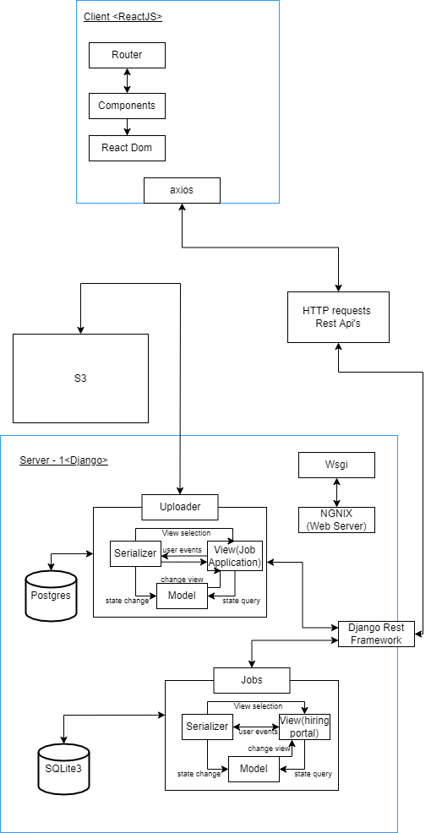

# Data Models

* Format the description properly. For instance, you may use a table. Moreover, briefly describe the important data fields as well.

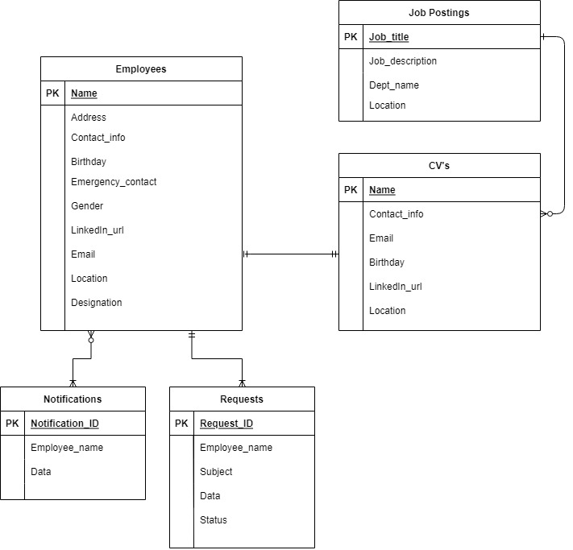

All the three tables shown in this ER Diagram are from 3 different SQLite databases. The Employees table is part of the AWS server(the 2nd server). These tables are in different databases so they will be connected to each other through HTTP requests, Rest APIs and django rest framework.

|  | Server | Information | Important Fields |
| --- | --- | --- | --- |
| Employee | AWS | It will have all information about the current employees of the company. All the attributes will be stored as strings. | The name will be the primary key and it will store the full name of an employee. |
| Job Postings | Django | It will store the information about all the active job postings. | There will be no duplicate active job titles at the same time. |
| CVs | Django | It will contain the data of the application form such as the applicant’s name, their contact information, their location and their LinkedIn profile url. The CV documents will be stored in amazon s3 storage. | The name, contact info and email will be primarily used to identify the applicants. |
| Notifications | AWS | Part of the DynamoDB, it will store all the notifications | Each notification will have its own unique ID. |
| Requests | AWS | Part of the DynamoDB, it will store all the employee request information | The status attribute in the requests table is for differentiating between approved/denied requests. |

# Tools and Technologies

* Backend: Django 3.8.2 or 4.0
* Frontend: React 17.0
* Databases: Amazon DynamoDB orAmazon DocumentDB 3.6
* Chatbot services: AWS Lex V2
* Servers/Serverless: AWS EC2, AWS lambda

# Who Did What?

| **Name of the Team Member** | **Tasks done** |
| --- | --- |
| Aamina Mariam | Section 2, Section 3 |
| Javeria Tariq | Section 2, Section 4 |
| Ali Adnan Arif | Section 2 |
| Mohammad Yousuf | Section 2 |
| Talha Nasir | Section 1, Section 2 |

# Review checklist

Before submission of this deliverable, the team must perform an internal review. Each team member will review one or more sections of the deliverable.

| **Section** **Title** | **Reviewer Name(s)** |
| --- | --- |
| Section 1 | Javeria Tariq |
| Section 2 | Aamina Mariam, Mohammad Yousuf |
| Section 3 | Javeria Tariq, Talha Nasir |
| Section 4 | Ali Adnan Arif |